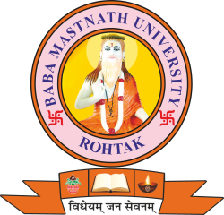
BABA MASTNATH UNIVERSITY
Asthal Bohar, Rohtak, NH-10, NCR, Haryana-124021(India)
Established under Haryana Private Universities Act, 2006
Recognized by the UGC u/s 2(f) and Member, Association of Indian Universities
Website: www.bmu.ac.in

Ref. No. ………………. Date ………….
Circular
It is hereby informed to all faculty members that the Internal Quality Assurance Cell (IQAC) is organizing a One Day Faculty Sensitization Program on NEP Implementation on 25th November 2025 (Tuesday).
The program will be held in the Mini Auditorium, Baba Mastnath University, and all faculty members from every department are required to be present by 2:00 PM sharp.
This sensitization program aims to enhance understanding of the National Education Policy (NEP) 2020, its key provisions, and its systematic implementation across the University. Your participation is essential to ensure effective academic and administrative alignment with NEP goals.
All Deans/Principals/HoD’s are requested to ensure full attendance of faculty members.

(Dean)

A copy is forwarded to the following persons:
- PS to Vice-Chancellor.
- Registrar.
- Dean Academic Affairs.
- Controller of Examinations.
- Dean Student Welfare.
- All Deans/Principals of the Faculties.
- All HoD’s of the Faculty.
- Director, IQAC.
- Head, IT Cell.
- Public Relation Officer (PRO).
- In-charge, Central Store.

